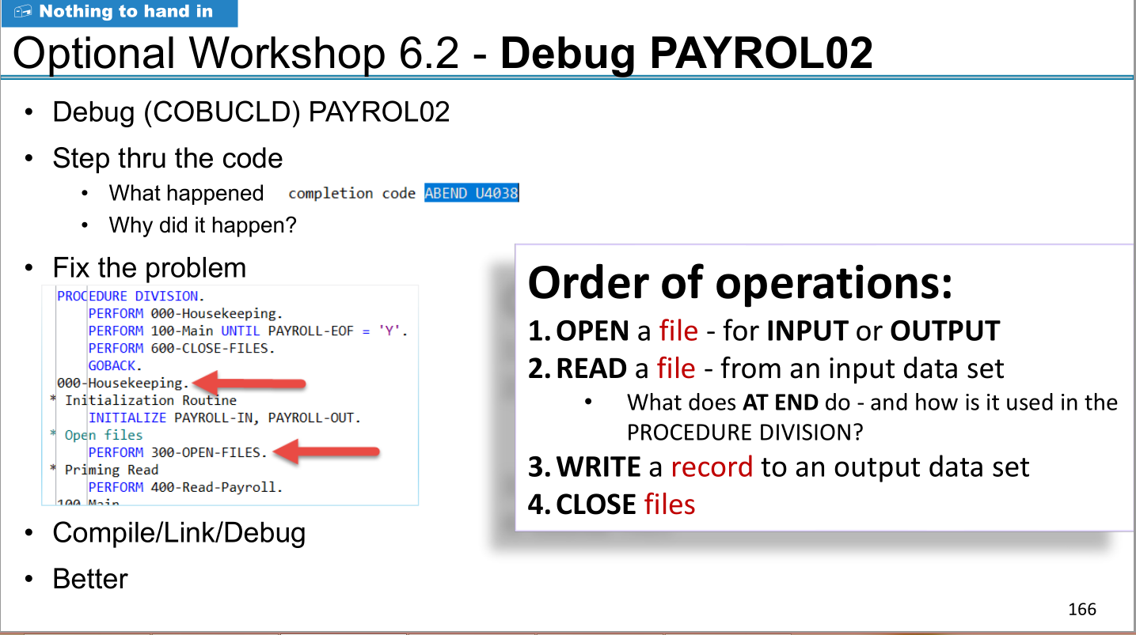

Solution : empty file / unfound file will lead to abend 4038 .

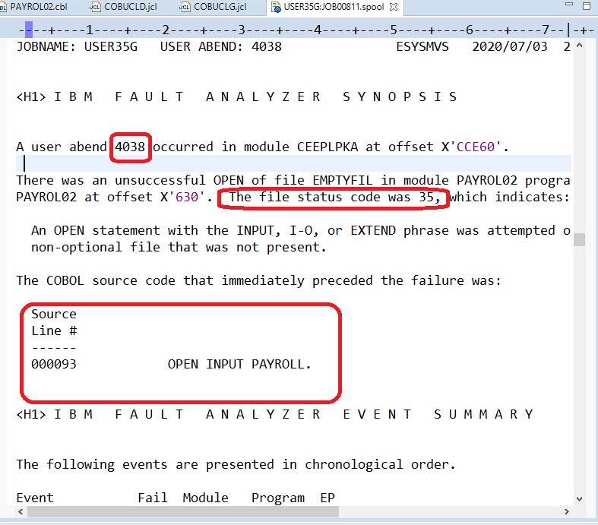

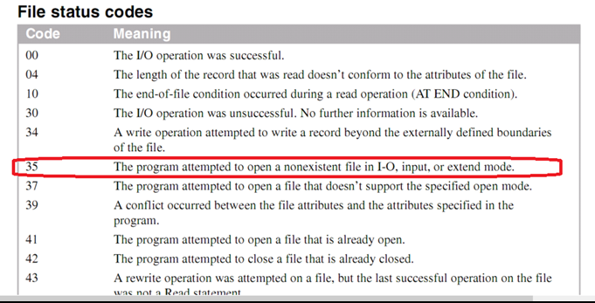

Question

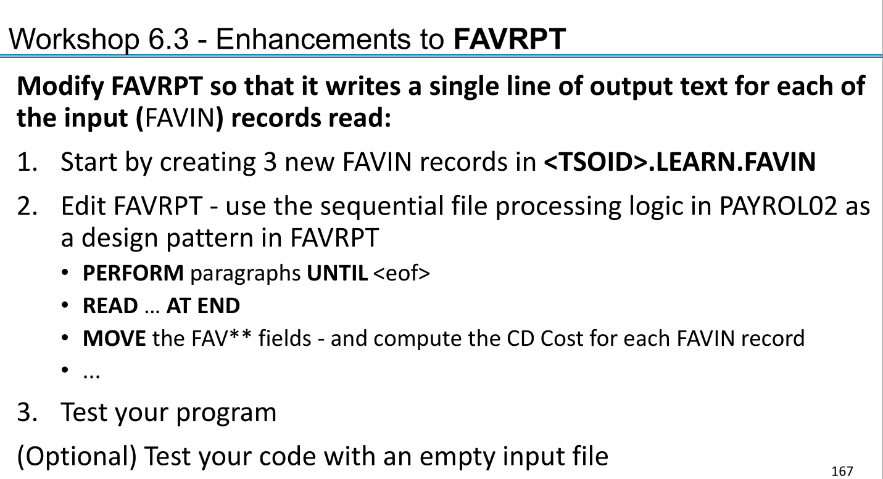

Answer : Report done with cost printed .

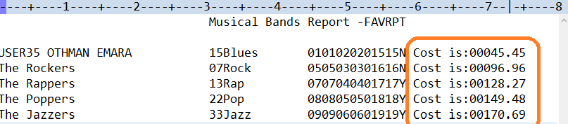

Code & debug picture below , for some reason the debug script giving JCL error .

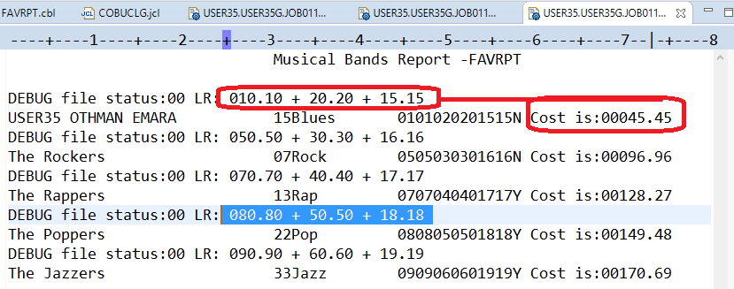

The code :

IDENTIFICATION DIVISION.

PROGRAM-ID. FAVRPT.

\*\*\*\*\* This MODULE Workshop 5.3.1b - Create new COBOL program

\*\*\*\*\* THAT USES A FILE READ

ENVIRONMENT DIVISION.

INPUT-OUTPUT SECTION.

FILE-CONTROL.

SELECT FAVIN1 ASSIGN TO FAVIN

FILE STATUS IS FAVIN-F-STATUS.

SELECT OUT2 ASSIGN TO FAVRPT.

DATA DIVISION.

FILE SECTION.

FD FAVIN1

RECORDING MODE IS F

LABEL RECORDS ARE STANDARD

RECORD CONTAINS 80 CHARACTERS

BLOCK CONTAINS 0 RECORDS

DATA RECORD IS FAVIN-REC.

01 FAVIN-REC.

05 ARTIST-NAME PIC X(30).

05 NUMBER-OF-MUSICIAN PIC 9(02).

05 MUSICAL-GENRE PIC X(12).

05 COST.

10 CD-COST PIC 9(3)V99.

10 SHIPPING-COST PIC 9(2)V99.

10 TAX PIC 9(2)V99.

05 BAND-IS-STILL-TOGETHER PIC X(1).

FD OUT2

RECORDING MODE IS F

LABEL RECORDS ARE STANDARD

RECORD CONTAINS 80 CHARACTERS

BLOCK CONTAINS 0 RECORDS

DATA RECORD IS FAVOUT-REC.

01 FAVOUT-REC.

05 ARTIST-NAME-OUT PIC X(30).

05 NUMBER-OF-MUSICIAN-OUT PIC 9(02).

05 MUSICAL-GENRE-OUT PIC X(12).

05 COST-OUT.

10 CD-COST-OUT PIC 9(3)V99.

10 SHIPPING-COST-OUT PIC 9(2)V99.

10 TAX-OUT PIC 9(2)V99.

05 BAND-IS-STILL-TOGETHER-OUT PIC X(1).

05 COST-IS PIC X(9) VALUE ' Cost is:'.

05 COMPUTED-COST-OUT PIC 9(5).99.

WORKING-STORAGE SECTION.

01 HEADER-1.

05 FILLER PIC X(30) VALUE SPACES.

05 FILLER PIC X(30) VALUE

'Musical Bands Report -FAVRPT'.

05 FILLER PIC X(20) VALUE SPACES.

01 DEBUG-REC.

05 FILLER PIC X(5) VALUE 'DEBUG'

JUSTIFIED

RIGHT.

05 FILLER PIC X(13) VALUE

' file status:'.

05 FAVIN-F-STATUS PIC X(2).

05 FILLER PIC X(4) VALUE ' LR:'.

05 LASTREC PIC X VALUE SPACES.

88 STELL-THERE-REC VALUE ' '.

88 NO-MORE-RECORDS VALUE 'Y'.

05 DBG-MESSAGE-ALL.

10 DBG-MESSAGE.

15 DBG-MSG1 PIC X(15).

15 DBG-MSG2 PIC X(15).

10 DBG-MSG3 PIC X(10).

10 DBG-MSG4 PIC X(10).

10 DBG-MSG5 PIC X(5).

01 COST-DEBUG.

10 CD-COST-D PIC 9(3).99.

10 FILLER PIC X(3) VALUE ' + '.

10 SHIPPING-COST-D PIC 9(2).99.

10 FILLER PIC X(3) VALUE ' + '.

10 TAX-D PIC 9(2).99.

77 COMPUTED-COST PIC 9(5).99.

PROCEDURE DIVISION.

OPEN INPUT FAVIN1.

OPEN OUTPUT OUT2.

WRITE FAVOUT-REC FROM HEADER-1.

MOVE SPACES TO FAVOUT-REC.

WRITE FAVOUT-REC AFTER ADVANCING 1 LINES.

\* Prime Read

PERFORM READ-RECORD.

PERFORM UNTIL LASTREC = 'Y' OR NO-MORE-RECORDS

PERFORM PROCESS-RECORDS

PERFORM WRITE-RECORD

PERFORM READ-RECORD

END-PERFORM

PERFORM CLOSE-FILES

STOP RUN.

READ-RECORD.

READ FAVIN1

\* AT END MOVE 'Y' TO LASTREC

AT END

PERFORM END-OF-FILE

\* NOT AT END PERFORM PROCESS-RECORDS

END-READ.

PROCESS-RECORDS.

COMPUTE COMPUTED-COST =(CD-COST + SHIPPING-COST + TAX).

MOVE CD-COST TO CD-COST-D .

MOVE SHIPPING-COST TO SHIPPING-COST-D .

MOVE TAX TO TAX-D .

MOVE SPACES TO DBG-MESSAGE-ALL.

\* MOVE ' P-RCD ' TO DBG-MSG1 .

\* WRITE FAVOUT-REC FROM DEBUG-REC.

\* Just to print debug data

\* MOVE COST-DEBUG TO DBG-MESSAGE .

\* WRITE FAVOUT-REC FROM DEBUG-REC.

WRITE-RECORD.

\* MOVE SPACES TO DBG-MESSAGE-ALL.

\* MOVE ' W-RCD ' TO DBG-MSG1 .

\* WRITE FAVOUT-REC FROM DEBUG-REC.

MOVE FAVIN-REC TO FAVOUT-REC.

MOVE COMPUTED-COST TO COMPUTED-COST-OUT.

MOVE ' Cost is:' TO COST-IS .

WRITE FAVOUT-REC.

CLOSE-FILES.

\* MOVE SPACES TO DBG-MESSAGE-ALL.

\* MOVE ' CLOS-FIL ' TO DBG-MSG1 .

\* WRITE FAVOUT-REC FROM DEBUG-REC.

CLOSE FAVIN1.

CLOSE OUT2.

END-OF-FILE.

MOVE 'Y' TO LASTREC.

\* MOVE SPACES TO DBG-MESSAGE-ALL.

\* MOVE ' E-O-FILE ' TO DBG-MSG1 .

\* WRITE FAVOUT-REC FROM DEBUG-REC.

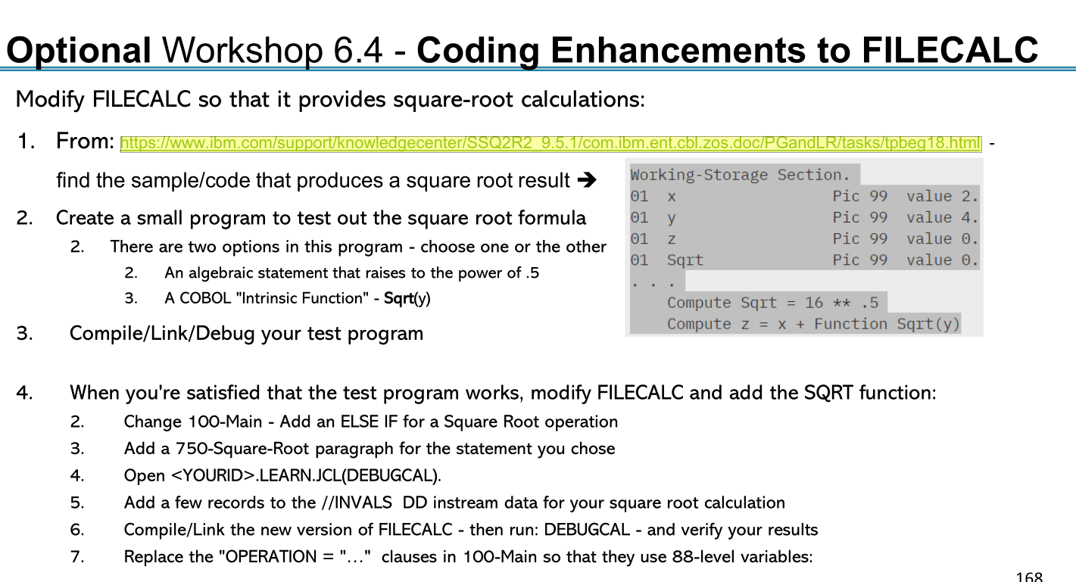

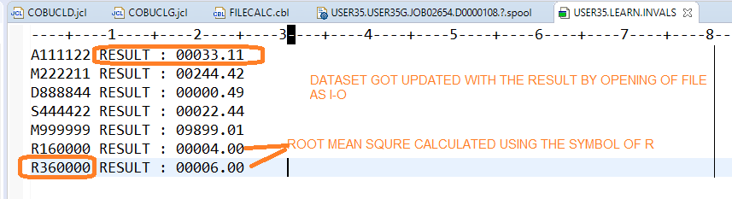

Also a report generated :

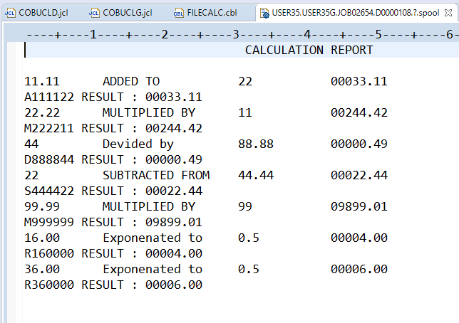

Code is :

IDENTIFICATION DIVISION.

PROGRAM-ID. FILECALC.

\* This program reads a file of input values into INVALS-WS

\* The operation read into the W-S structure drives the arithmetic

ENVIRONMENT DIVISION.

INPUT-OUTPUT SECTION.

FILE-CONTROL.

SELECT INVALS ASSIGN TO INVALS ORGANIZATION IS SEQUENTIAL.

SELECT REPORTFILE ASSIGN TO PRTLINE.

DATA DIVISION.

FILE SECTION.

FD INVALS

RECORDING MODE IS F

LABEL RECORDS ARE STANDARD

RECORD CONTAINS 80 CHARACTERS

BLOCK CONTAINS 0 RECORDS

DATA RECORD IS INVALS-REC.

01 INVALS-REC PIC X(80).

FD REPORTFILE

RECORDING MODE IS F

LABEL RECORDS ARE STANDARD

RECORD CONTAINS 80 CHARACTERS

BLOCK CONTAINS 0 RECORDS

DATA RECORD IS REPORT-REC.

01 REPORT-REC .

05 VAL1-RPT PIC X(10) VALUE SPACES .

05 OPERATION-CODE PIC X(20) VALUE SPACES .

05 VAL2-RPT PIC X(10) VALUE SPACES .

05 EQUAL-TEXT PIC X(3) VALUE ' = ' .

05 RESULT-RPT PIC 9(5).99 VALUE ZEROS .

05 FILLER PIC X(20) VALUE SPACES .

WORKING-STORAGE SECTION.

\* End of File switch

01 INVALS-EOF PIC X(1) VALUE SPACE.

88 EOF-REACHED VALUE 'Y'.

01 INVALS-WS.

05 OPERATION PIC X(1) .

88 ADD-OPERATION VALUE 'A' 'a'.

88 SUBTRACT-OPERATION VALUE 'S' 's'.

88 MULTIPLY-OPERATION VALUE 'M' 'm'.

88 SQUARE-ROOT-OPERATION VALUE 'R' 'r'.

88 DIVIDE-OPERATION VALUE 'D' 'd'.

05 INVALS-1 PIC 99V99.

05 INVALS-2 PIC 99.

05 INVALS-2X REDEFINES INVALS-2 PIC X(2).

05 TEXT1 PIC X(10) VALUE ' RESULT : ' .

05 INVALS-RZLT PIC 99999.99.

01 HEADER-1.

05 FILLER PIC X(30) VALUE SPACES.

05 FILLER PIC X(30) VALUE ' CALCULATION REPORT '.

01 INVALS1-EDITED PIC 99.99.

01 INVALS-1X REDEFINES INVALS1-EDITED PIC X(5).

PROCEDURE DIVISION.

PERFORM 000-Housekeeping.

PERFORM 100-Main UNTIL EOF-REACHED.

PERFORM 900-CLOSE-FILES.

GOBACK.

000-Housekeeping.

INITIALIZE INVALS-WS.

PERFORM 300-OPEN-FILES.

WRITE REPORT-REC FROM HEADER-1.

MOVE SPACES TO REPORT-REC.

WRITE REPORT-REC AFTER ADVANCING 1 LINES.

\* Priming Read

PERFORM 400-Read-INVALS.

100-Main.

PERFORM 320-PROCESS-RECORDS

PERFORM 350-REWRITE-RECORD

PERFORM 400-Read-INVALS .

300-OPEN-FILES.

OPEN I-O INVALS.

OPEN OUTPUT REPORTFILE.

320-PROCESS-RECORDS.

IF ADD-OPERATION PERFORM 500-ADD

ELSE IF SUBTRACT-OPERATION PERFORM 600-SUBTRACT

ELSE IF MULTIPLY-OPERATION PERFORM 700-MULTIPLY

ELSE IF SQUARE-ROOT-OPERATION PERFORM 750-SQUARE-ROOT

ELSE IF DIVIDE-OPERATION PERFORM 800-DIVIDE

END-IF.

\* DISPLAY INVALS-1.

\* DISPLAY INVALS-2.

\* DISPLAY INVALS-RESULT.

350-REWRITE-RECORD.

\* Although updating with calculated field is redundancy

STRING INVALS-1X

DELIMITED BY SIZE INTO VAL1-RPT .

STRING INVALS-2X

DELIMITED BY SIZE INTO VAL2-RPT.

IF SQUARE-ROOT-OPERATION

MOVE '0.5' TO VAL2-RPT

ELSE IF SUBTRACT-OPERATION OR DIVIDE-OPERATION

\* just for Report formt Switching values due to subtracting x from y

MOVE INVALS-2X TO VAL1-RPT

MOVE INVALS-1X TO VAL2-RPT

END-IF.

MOVE INVALS-RZLT TO RESULT-RPT .

MOVE ' RESULT : ' TO TEXT1 .

WRITE REPORT-REC

WRITE REPORT-REC FROM INVALS-WS.

REWRITE INVALS-REC FROM INVALS-WS.

400-Read-INVALS.

READ INVALS INTO INVALS-WS AT END MOVE "Y" TO INVALS-EOF

DISPLAY INVALS-WS .

MOVE ZEROS TO INVALS-RZLT .

DISPLAY INVALS-WS .

MOVE FUNCTION UPPER-CASE(OPERATION) TO OPERATION.

INITIALIZE REPORT-REC.

COMPUTE INVALS1-EDITED = INVALS-1 .

500-ADD.

ADD INVALS-1 , INVALS-2 GIVING INVALS-RZLT.

MOVE ' ADDED TO ' TO OPERATION-CODE .

600-SUBTRACT.

SUBTRACT INVALS-2 FROM INVALS-1 GIVING INVALS-RZLT .

MOVE ' SUBTRACTED FROM ' TO OPERATION-CODE .

700-MULTIPLY.

MULTIPLY INVALS-1 BY INVALS-2 GIVING INVALS-RZLT .

MOVE ' MULTIPLIED BY ' TO OPERATION-CODE .

750-SQUARE-ROOT.

COMPUTE INVALS-RZLT = FUNCTION SQRT( INVALS-1 ) .

MOVE ' Exponenated to ' TO OPERATION-CODE .

800-DIVIDE.

DIVIDE INVALS-2 BY INVALS-1 GIVING INVALS-RZLT .

MOVE ' Devided by ' TO OPERATION-CODE .

900-CLOSE-FILES.

CLOSE INVALS.

CLOSE REPORTFILE.